**Web hosting Assessment**

**Objective:**

Deploy and configure an Apache web server to host multiple websites, including package installation, virtual host setup, permission adjustments, security configurations, and firewall settings.

**sudo yum install httpd –y -** Installs Apache (httpd) on a Linux system using the YUM package manager. The -y flag automatically confirms installation.

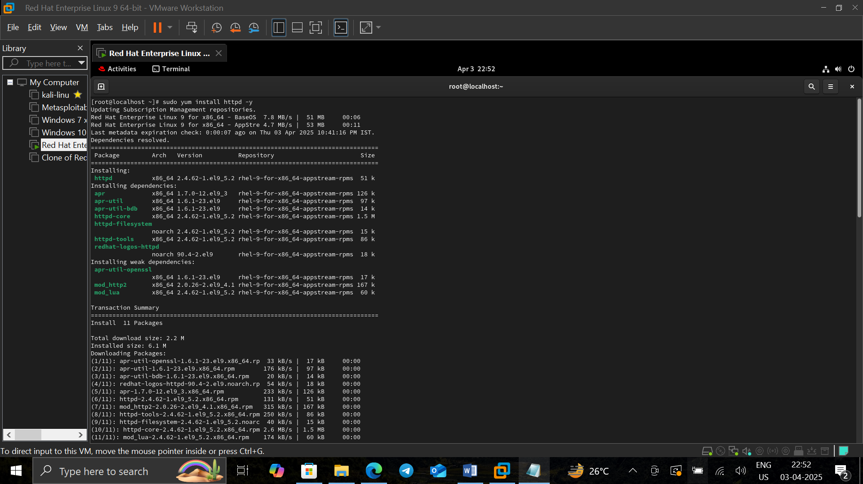

**sudo systemctl start httpd -** Starts the Apache web server.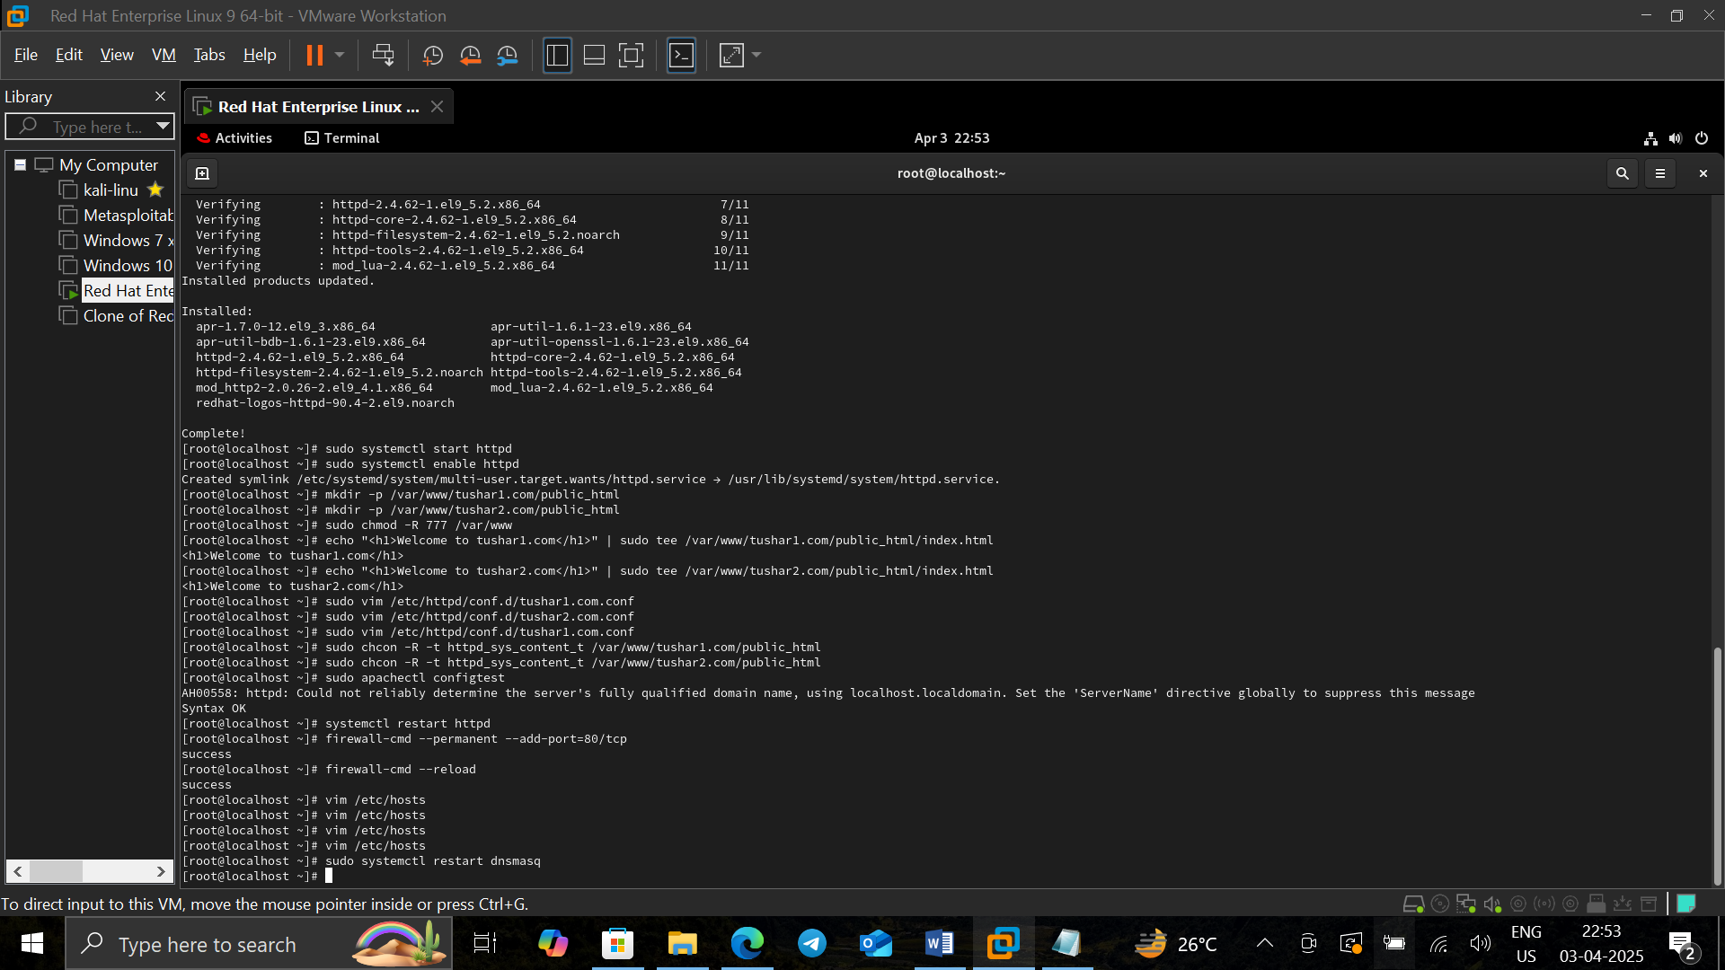

**Sudo systemctl enable httpd -** Enables Apache to start automatically on system boot.



**sudo mkdir -p /var/www/example1.com/public_html -** Creates a directory structure for the first website (example1.com).



**sudo mkdir -p /var/www/example2.com/public_html -** Creates a directory structure for the second website (example2.com).

**sudo chmod -R 777 /var/www -** Grants full permissions (read, write, execute) to all users for the /var/www directory.



**echo "<h1>Welcome to Example1.com</h1>" | sudo tee /var/www/example1.com/public_html/index.html -** Creates an index.html file for example1.com with a simple HTML heading.

**echo "<h1>Welcome to Example2.com</h1>" | sudo tee /var/www/example2.com/public_html/index.html -** Creates an index.html file for example2.com with a simple HTML heading.



**sudo vim /etc/httpd/conf.d/example1.com.conf -** Opens a configuration file for example1.com using the vim editor.



**vim /etc/httpd/conf.d/example2.com.conf -** Opens a configuration file for example2.com using vim.



**sudo chcon -R -t httpd_sys_content_t /var/www/example1.com/public_html -** Applies the correct SELinux security context for Apache to access the example1.com directory.



**sudo chcon -R -t httpd_sys_content_t /var/www/example2.com/public_html -** Applies the correct SELinux security context for Apache to access the example2.com directory.



**sudo apachectl configtest -** Checks the Apache configuration for syntax errors before restarting the service.



**sudo systemctl restart httpd -** Restarts the Apache service to apply changes



**sudo firewall-cmd --permanent --add-port=80/tcp -** Opens port 80 (HTTP) on the firewall to allow web traffic.

**sudo firewall-cmd –reload -** Reloads the firewall rules to apply the new settings.



**vim /etc/hosts -** Opens the /etc/hosts file in vim to configure hostname resolution.